Carrot U Assignment Tracker

*Authored by Kenneth Lekashman Last updated on Dec 6th 2019*

This project aims to provide visibility into Carrot University completed student coursework. By instituting an automated tracker we will be able to have greater into visibility about how students are keeping up and provide statistics on drop off.

# Overview

## Problem

1. **We don’t track who drops out when or why:** 2019 marked a year of significant interest in participation. Carrot University was unable to sufficiently pair mentors with interested applicants. As there is growing interest in the program, identifying if there is a common trend of drop-offs might mean a particular segment of the coursework could use re-working.
2. **HR has asked for statistics on assignment completion** :In order to receive additional funding to be able to support growing demand for Carrot U courses, providing statistics on student assignment completion will enable HR to better fund the program.
3. **Adding a tracker for competition has proven results in education**: Making the tracker a public asset will allow students to see who is completing assignments as well as who they might potentially ask for help if they are struggling to keep up.

## Goals

1. **Provide visibility into Student Assignment Participation:** We want to see where student drop-off is occuring.
2. **Require minimal tracking or data collection by Carrot U staff**: We want to avoid creating a system that requires staff to tally or ‘grade’ assignments.
3. **Create a scalable solution:** We do not want to have to continue to add assignment tracking information or have the program work for a set number of students.

## Out of Scope

1. **Quality of Assignment Submissions**: We will not be providing “grades” on the assignment, that will still be administered by staff/mentors.
2. **Internship or Career Prospects**: The tracker at present will not be used for where alums go on.

## People and Roles

1. **Muffy (carrot u staff)**: Distribute tracker form to students. Project Sponsor
2. **Dave (carrot u staff)**: Distribute tracker form to students. Project Sponsor
3. **Kenneth (tableau developer)**: build & qa a tracker tableau dashboard
4. **Unnamed HR (HR)**: Using provided statistics to inform future Carrot U
5. **Carrot U students (users):** Will be tracking in the tool.

# Context

## Use Cases

1. **Users want to:**
   1. **Check in assignments in 30 seconds or less**: Students have already had to complete the assignment and submit to github the submission should be entirely painless.
   2. **On mobile or desktop**: As long as the github link is active the system should be agnostic of device for example if completing on a personal computer student should be able to submit.
2. **Staff wants to**:
   1. **View Student info**: Clearly understand how the students are getting on with the course and see drop-off.
   2. **Not have to Add/reduce students**: Staff has enough to do in volunteering their time, having to tally or collect submissions is not an option.
   3. **Not need to Update Assignment Weekly**: System should scale as the coursework progresses and not require updating from week to week.
3. **HR wants to:**
4. **View student drop-off**: Assessing where students are dropping off in the program can allow them to properly budget for future programs.  
   Any data can only help Carrot U grow further.

# Proposal

Like most things in life. This particular problem can be solved with the creation of a great Tableau dashboard.

## Tableau

I picked Tableau as they are an existing Instacart vendor. In addition their tool is built for scalable data problems to provide increased visibility and insight into reporting and tracking.

## Google Sheets

I picked Google Sheets for the form submission as they are an existing pre-approved vendor. In addition Tableau has a live data connector to a Google Sheet form to allow for live updating.

## User Experience

At present after a Carrot University student has successfully completed an assignment their final step is to check in their work into Github in order to have their assignment accepted and viewed by their respective Carrot U mentor.

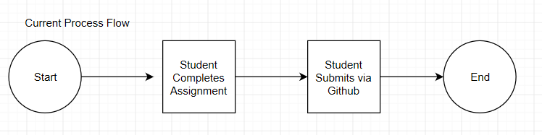

Under the newly proposed Future State we will be providing one more additional step in which the student will after completing their check in on Github, will now complete an additional submission into a Google Form Tracker after the completion of an assignment.  
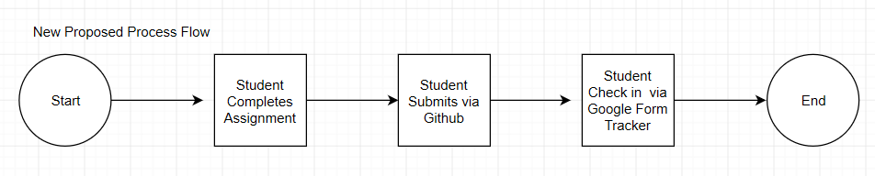

Students will only be interacting with the [Google Form tracker](https://docs.google.com/forms/d/e/1FAIpQLSfPoYk_zmGRGoDcQ9HpZ2KZEOxX-cB6c__4UJ1ceqB_udOuUw/viewform) in Google Forms which will in turn be submitting the data of their submissions into a live [Google Drive Sheet.](https://docs.google.com/spreadsheets/d/1DOFfZTHz-vDIqaJvyARciGk19eFODIvhDP4owhB28S8/edit#gid=1880831769)

Tracker Survey Questions

1. **Name:** This is used for continuity, a student must consistently submit with their same spelling in name in order for the tracker to consistently track.
2. **When did your cohort begin**: This field is used for tracking purposes. In order for HR/Staff to view statistics by different cohorts all they need to do is edit a filter. At the start of a cohort, staff will need to add the current cohort year.
3. **What # assignment did you complete:** As assignments schedules for submission vary, some with due dates of 1 week others with 2 weeks this question was phrased to provide the easiest visibility. As for our purposes we do not need to know the exact ‘day’ persey of drop-off but more so need a general time the assignment # will yield sufficient insight. In addition the students are already primed to know what number assignment they are on, identifying the week of program might not be viable.
4. **On a scale of 1-10 how difficult was this assignment**: this question is used as a general hypothesis for the program would the level of challenge especially early on might correlate strongly with student drop-off.
5. **What is your @instacart email:** This is used purely in case a staff member needs to easily access or get a hold of a student based off their submission or any other reason
6. **Share a link to your github assignment:** This is provided as a “proof of completion”.

## Tableau Dashboard Workbooks:

We will be only using the fields of name & assignment number & number of records in order to provide overall visibility into task completion.

1. **Last Assignment Submitted**: This will provide a quick view into where students are dropping.
2. **Tracker:**  if a student enters one submission they will receive a square, if a student “missed a week” but continues to submit assignments this will provide that visibility.
3. **# of submissions for each assignment:** This is a baseline aggregate by assignment which will show the overall participation trend
4. **Cumulative Assignment Submission:** This gives a heavy top-line number at the end of the course for HR and staff.

Example Screencap of Dashboard in Production a link can been seen here for the [live dashboard](https://tableau.fernet.io/#/views/CarrotUTracker/CarrotUTracker?:iid=1):

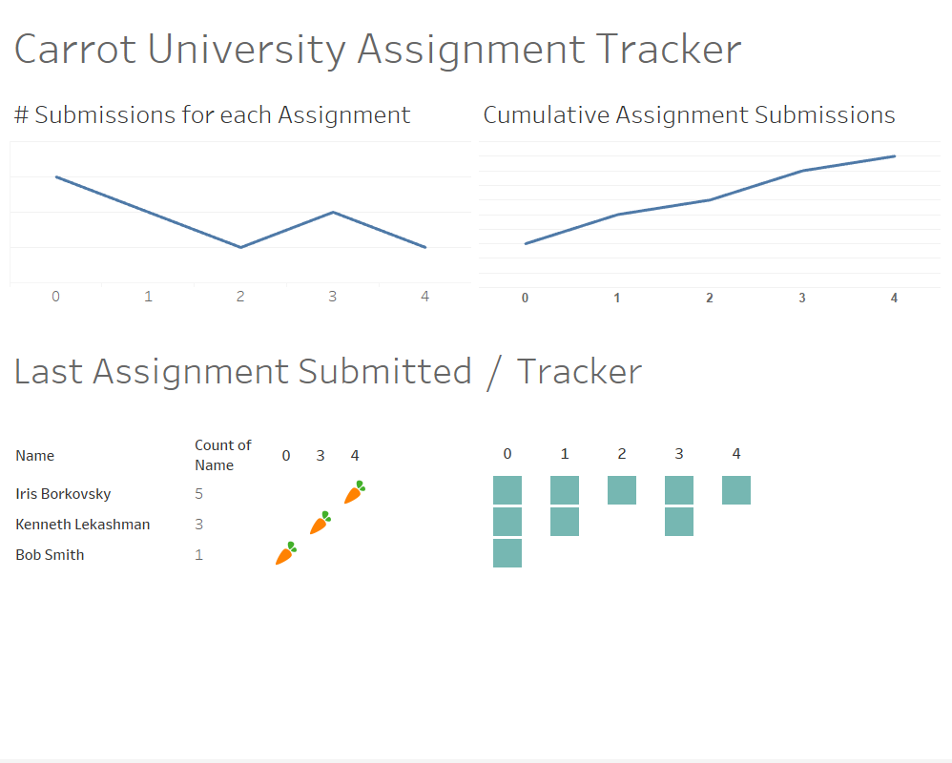

## Future Work

1. **If we see very little student participation:** Then we need to better incentivize the completion and ensure understand that their submission is tied to review and continued participation.
2. **If the test succeeds**: we’ll be able to identify drop-off and allow more people at the start of termat next cohort in order to ensure the program is properly staffed and funded.

# Tasks

1. **Dec 8th:** [Dashboard creation](https://tableau.fernet.io/#/views/CarrotUTracker/CarrotUTracker?:iid=1)
2. **Dec 10th:** Dashboard review by Carrot U staff
3. **Dec 17th:**  launch of current completed coursework students. We will need students to submit the back-log of completed weeks 1-3 at time as well.
4. **January 6th:** Review tracker and ensure data is properly importing in and maintaining formatting.
5. **June**: Review statistics